Exercise: Android Service
Document Number: |  | Issue Number:  Date:

TABLE OF CONTENTS
1 Exercise 1: Create a simple music player with Started Service 2
1.1 Description. 2
1.2 Create new Project. 2
1.3 Design layout for Main Activity. 2
1.4 Add a music file (.mp3) in res/raw/. 3
1.5 Create a new class extend Service and declare this class in AndroidManifest.xml. 4
1.6 Implement button event in Main Activity. 5
2 Exercise 2: Create a simple music player with Bind Service 5
2.1 Description. 5
2.2 Create new Project. 5
2.3 Design layout for Main Activity 6
2.4 Add a music file (.mp3) in res/raw/ 7
2.5 Create a new class extend Service and declare this class in AndroidManifest.xml 8
2.6 Implement button event in Main Activity. 9

Exercise 1: Create a simple music player with Started Service

Description.
The purpose of this exercise is make students get familiar with Started Service in Android software development. At the end of this exercise, student knows and can use Started Service to build application.
Expected result: The application will have 2 buttons: Play and Stop. When user presses on Play, the music will be play and continue playing even the activity is destroyed. The music only stops when user chooses Stop button.

Create new Project.
In Eclipse, create new project with default activity.

Design layout for Main Activity.
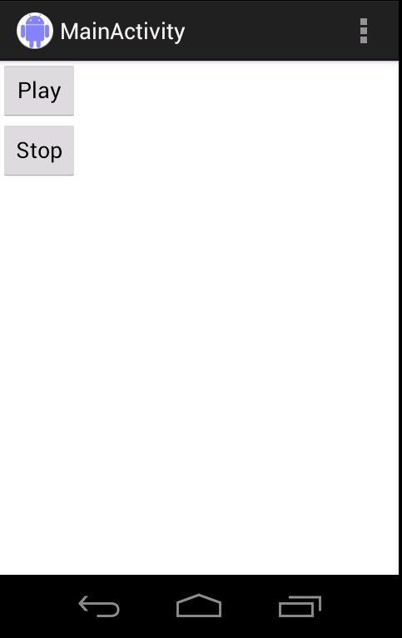

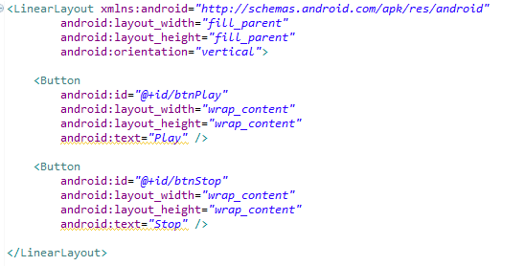

Add a music file (.mp3) in res/raw/.
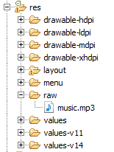

Create a new class extend Service and declare this class in AndroidManifest.xml.
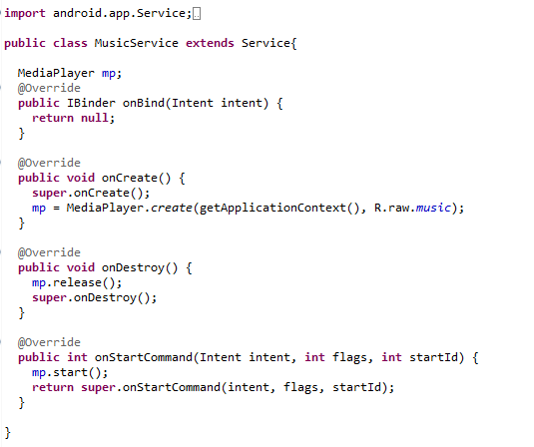

Implement button event in Main Activity.
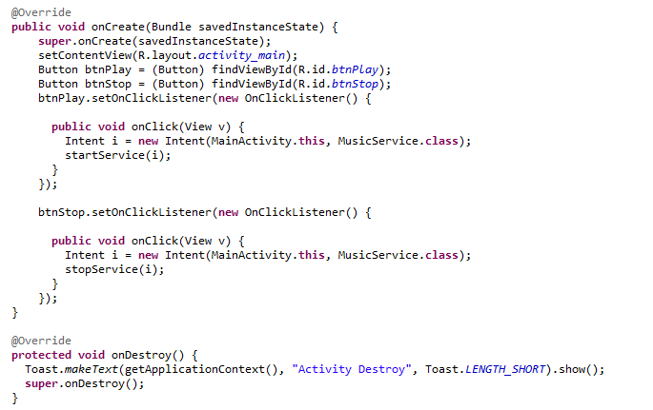

Exercise 2: Create a simple music player with Bind Service

Description.
The purpose of this exercise is make students get familiar with Bind Service in Android software development. At the end of this exercise, student knows and can use Bind Service to build application.
Expected result: The application will have 3 buttons: Play, Pause and Stop. When user presses on Play, pause music when presses Pause and stop when press Stop. The music will stop when activity associate with service is destroyed.

Create new Project.
In Eclipse, create new project with default activity.

Design layout for Main Activity
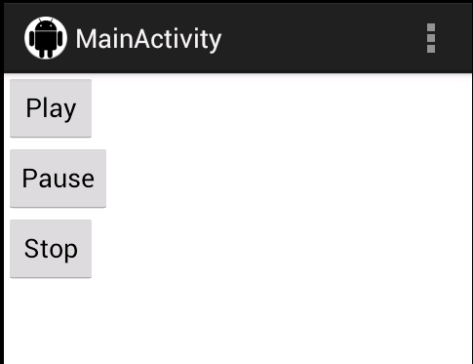

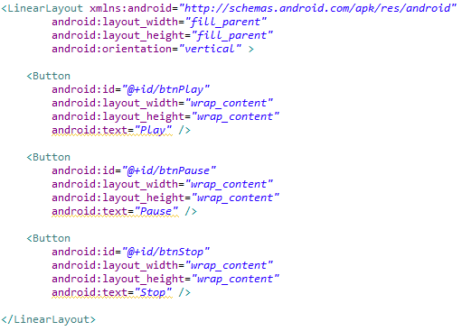

Add a music file (.mp3) in res/raw/

Create a new class extend Service and declare this class in AndroidManifest.xml
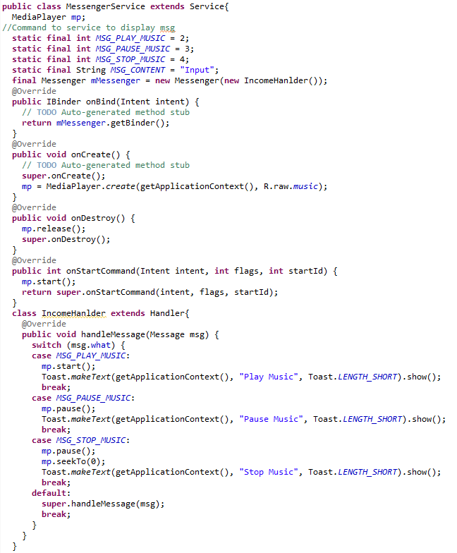

Implement button event in Main Activity.
